Veit SG66
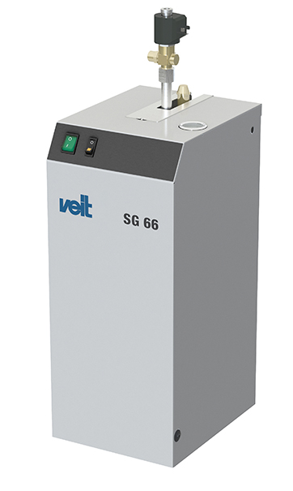

Your small, long-life steam generator

Advantages:
- 2.2 kW – 230 V for 3.0 kg steam/h, solenoid valve for connection the iron
- Compact steam generator with long-life stainless steel boiler
- Automatic water feed-in through built-in pump (for direct water connection or feedwater tank)
- Acoustical and optical water level indicator
- Safety features same as SG 67
- No direct water connection necessary
- Includes safety blow-down tank

