Veit SG67 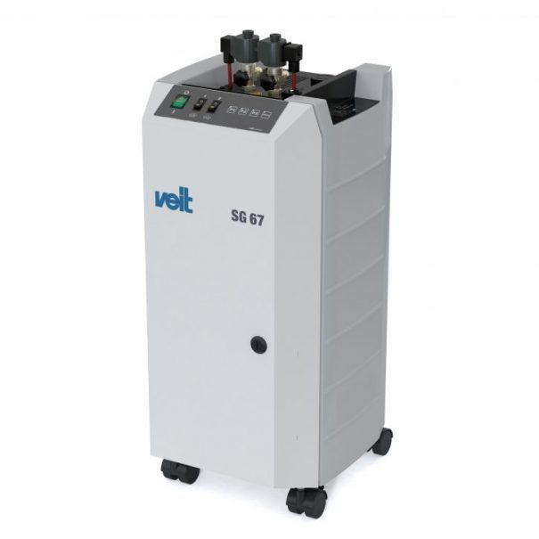
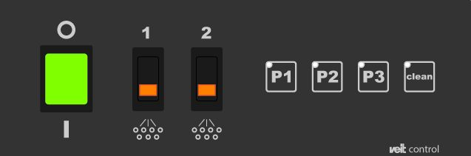

Taking Steam Generators to the next level
With their high-quality workmanship, VEIT steam generators are suitable for non-stop operation in a very wide range of industrial applications.
This small electro steam generator SG 67 is designed for continuous operation in the following industrial applications garment and textiles industry, automotive industry, chemical industry, production and laboratories, hospitals and pharmacies, food and beverage sector, packaging sector, iron and steel industry.

Advantages:
- Adjustable steam quality
- Easy access
- Stainless steel boiler
- Direct water connection without additional container
- Longer operating hours without refilling
- Integrated locking castors
- Safe automatic filling
- Operation with distilled water* and reverse osmosis water possible
- Versatile connections
- Integrated iron connections
- Top facing valve for blow-down
- Small dimensions
Options:
 | 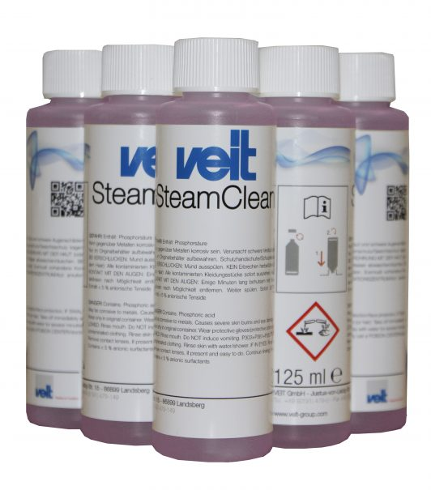
LAPIDON | STEAMCLEAN

