Veit Varioline CR2 S+B
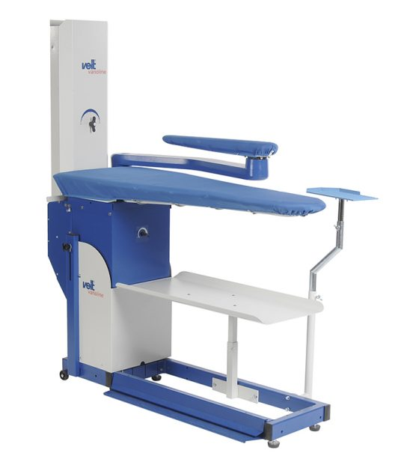

For studios, tailor shops, refinishers and textile care

Advantages:
- Suction and blowing table
- Ironing surface: 1400x500x320 mm
- Outstanding suction and blowing power with manual power adjustment for short drying and cycle times
- Foot pedal control
- Universal ironing table /flat top for trousers, dresses, skirts, coats, blouses and other garments
- Low noise level
- No heating of surface necessary
- Comfortable height adjustment supported by gas spring

