Veit Varioset CR2 S+B
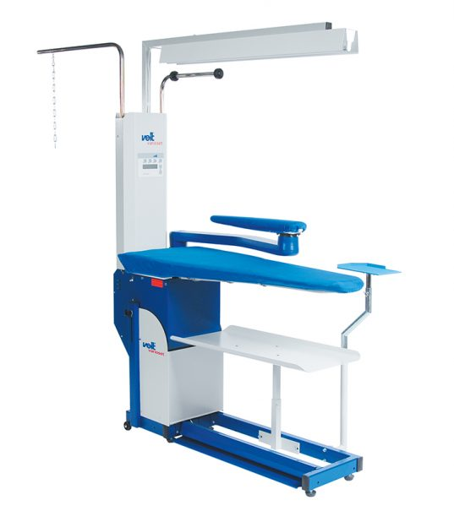

Contact your sales partner now

For studios, tailor shops, refinishers and textile care

Advantages:
- Suction and blowing table
- Superior suction and blowing power with independently adjustable air power for fast drying and cycle times
- Ironing surface: 1400x500x320 mm
- Foot pedal control
- Low noise level due to elaborate flap box
- No heating of surface necessary
- Comfortable height adjustment supported by gas spring
- Electronic control unit with display and integrated
- Optionally available with integrated egg-shaped buck for optimal ironing of wider parts of the garment

